Constituency Syntax

Source: https://people.ischool.berkeley.edu/~dbamman/nlp20_slides/13_syntax.pdf

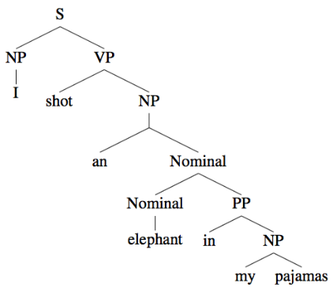
Syntax
- Progress from labels for items (documents → sentiment analysis, tokens → POS tagging/NER) to structure between items
- POS indicative of syntax and pronunciation
- Context-free grammar (CFG) defines valid structure in a language
- Derivation to generate a sentence from constituents can be visualized as a parse tree

Evaluation
- Parseval: compare parsers through tuples in trees

Treebank
- Collection of sentences annotated with syntactic structure
- Automatically create CFG by extracting rules from annotations
- Probabilistic context-free grammar used to find best parse through highest probaility

